**Melbourne Fire Doors Smart Door frame Modification Quote**

**Date 28/05/2020**

**Item No1**

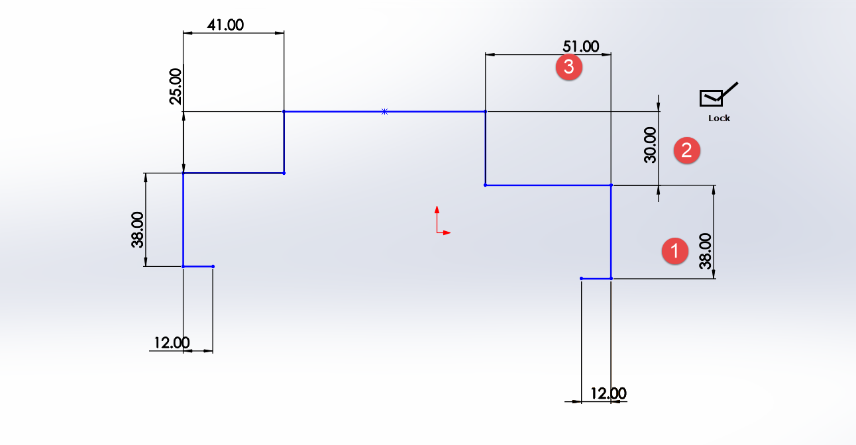

Make Sizes 1,2,3 Variable if check box is unticked

**Item No2**

Add Legs

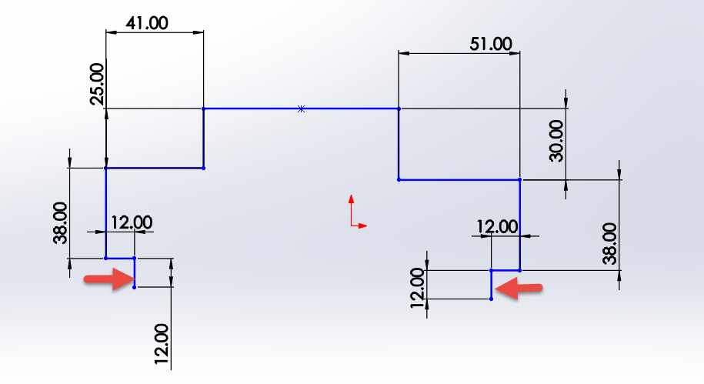

**Item no3**

A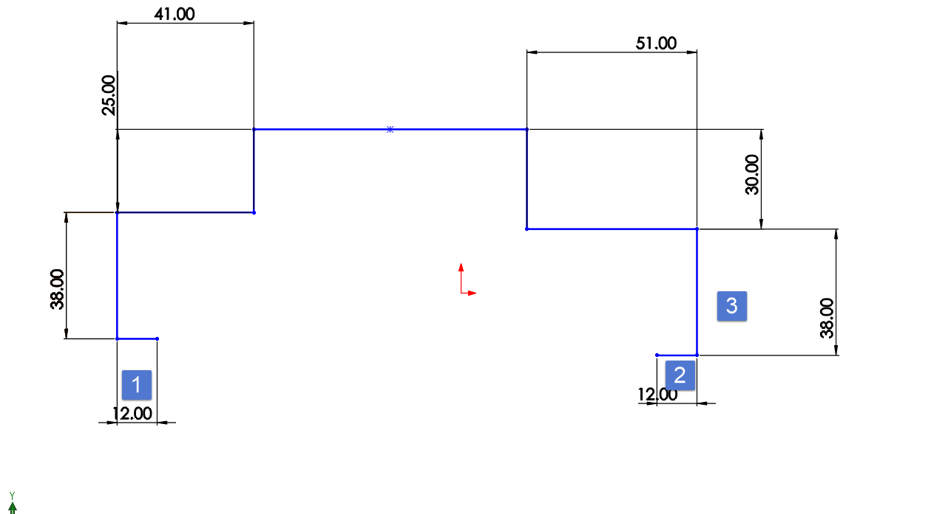

Ability to make

No 1,2,3 to the value of “0”

Shape would look like

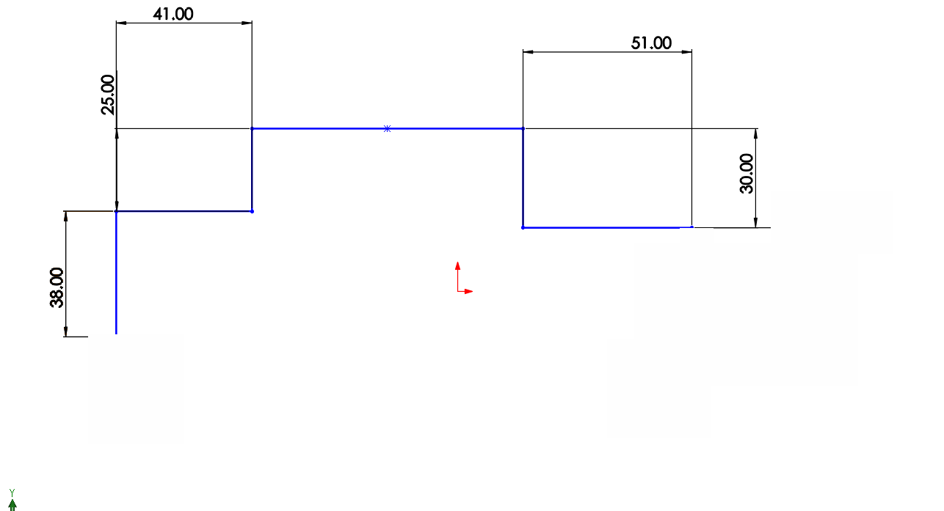

**Single Rebate**

Item No4

Add legs  
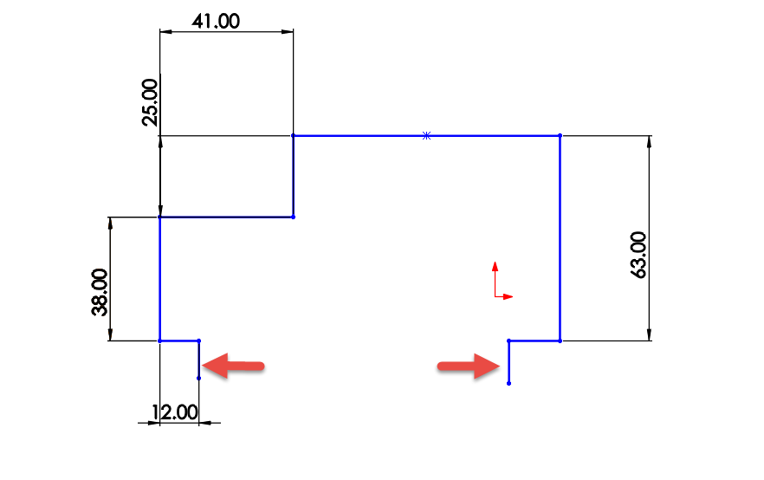

Item no 5

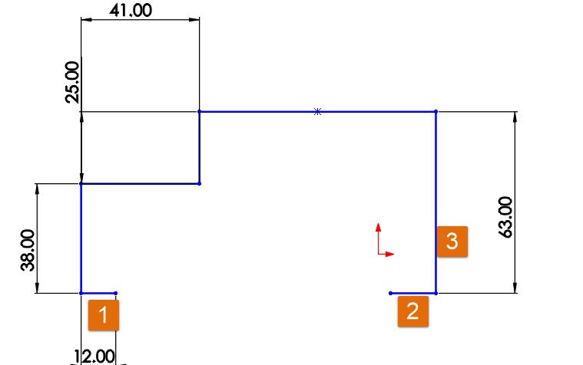  
Make Item no 1,2,3 as 0

Resulting shape

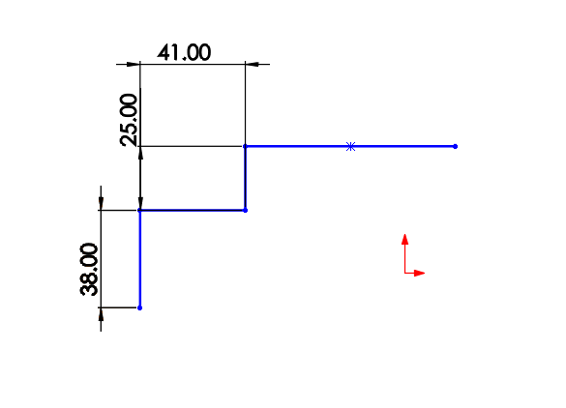

Item No 6  
Add 2.0 Gauge *( Kevin to send sample for both Single and double rebate)*

Item No 7   
Add New Hinge Quantity

Current New   
 2 2  
 3 3

4 4

5

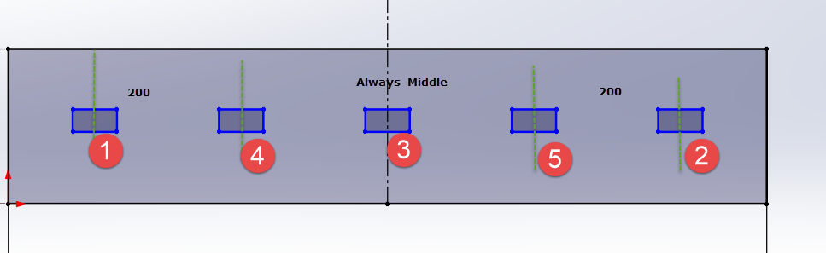

2,3,4 are working fine , add 5th at the bottom

Item No8  
Add 2 New Lock types *( Kevin to send the cut out drawings )*

ES-2000  
FES-10

Item No 9

New Options to add holes on Rebates   
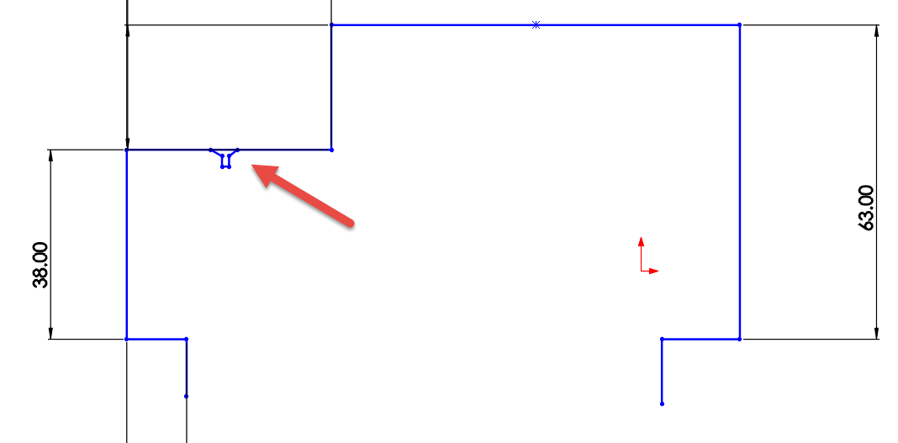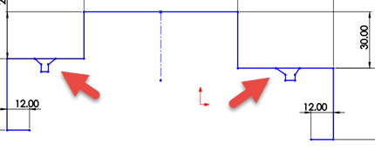

Item No 10

Change Hole positions as below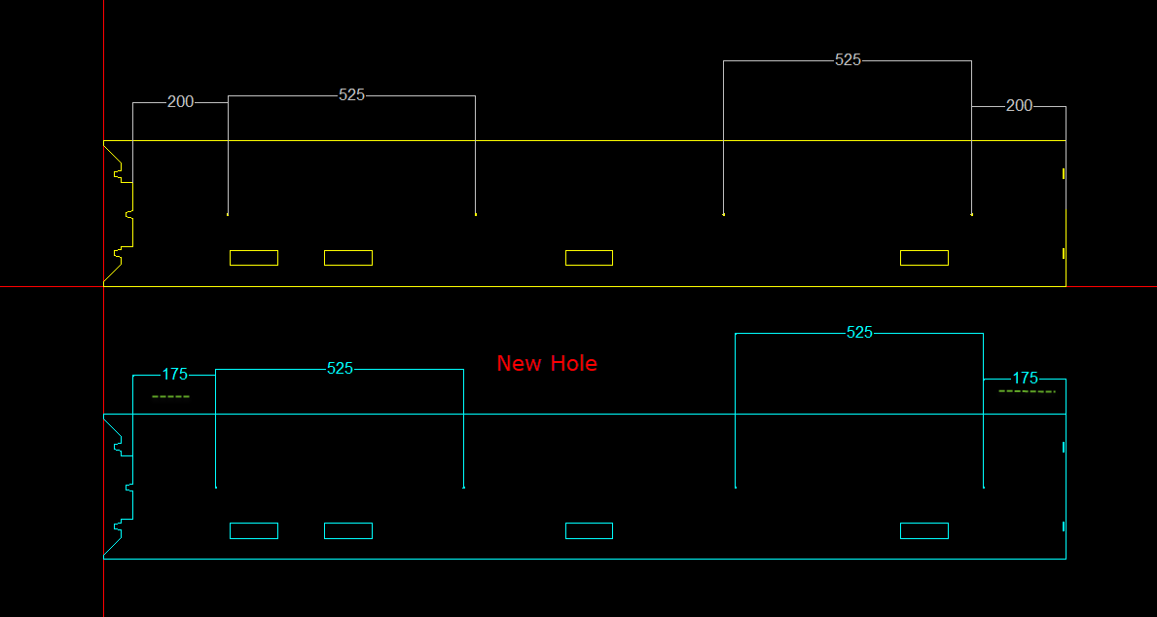

Item no11

Add C frame option



Cost :